Name-Shreya Panda
PRN – 25070122181
Class- B3 (25-29)
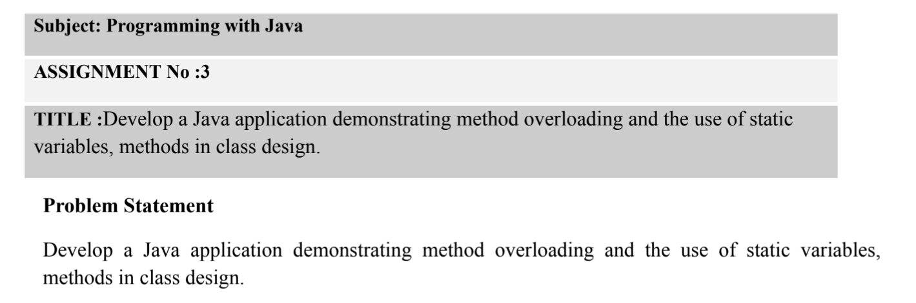
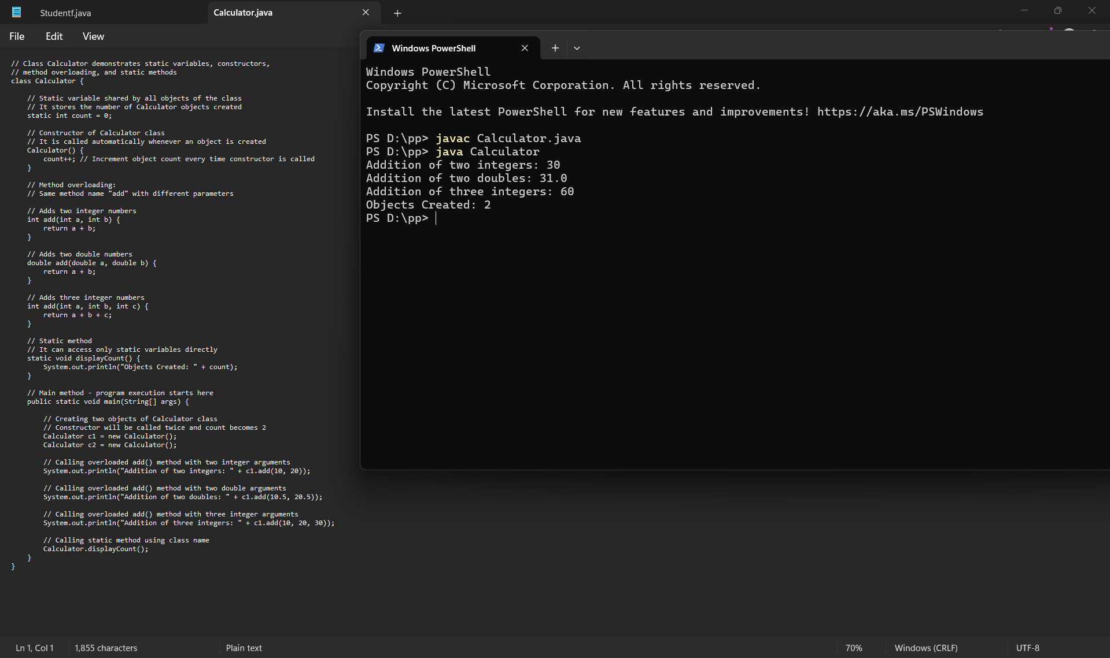
Conclusion
This assignment successfully demonstrates the implementation of method overloading and static members in Java. The Calculator program uses overloaded methods to perform addition for different data types, illustrating compile-time polymorphism. A static variable is used to count the total number of calculations, while static methods provide shared functionality across all objects. Overall, the assignment enhances the understanding of method overloading, static variables, and static methods, showing how these features improve code reusability, efficiency, and maintainability in Java applications.

